LAYERED SECURITY ANALYSIS AND EXECUTABLE QUALITY ASSURANCE FOR AGENT-GENERATED CODE IN THE AUTOFORGE MULTI-AGENT PIPELINE
Individual Thesis
Oberathna R.D.T.D.
IT22102478
Component: Security Analysis and Quality Assurance
Group ID: R26-SE-033
Thesis submitted in partial fulfilment of the requirements for the
Bachelor of Science (Honours) in Information Technology
Specialising in Software Engineering
Department of Software Engineering
Sri Lanka Institute of Information Technology
Sri Lanka
October 2026

DECLARATION AND SUPERVISOR CERTIFICATION
Candidate declaration. I declare that this thesis is my own work and does not incorporate, without acknowledgement, material previously submitted for a degree or diploma at any university or institute of higher learning. To the best of my knowledge, it contains no material previously published or written by another person except where acknowledgement is made in the text. I grant the Sri Lanka Institute of Information Technology the non-exclusive right to reproduce and distribute this thesis, in whole or in part, in print, electronic, or other media, while retaining the right to use the content in future work.
Academic integrity and AI disclosure. I have disclosed all use of generative AI and other automated tools in accordance with the module policy. I remain responsible for the accuracy, originality, citations, code, data, analyses, and conclusions in this thesis.
Student name | Student ID | Signature | Date
Oberathna R.D.T.D. | IT22102478
Supervisor certification. The above candidate carried out this research for the bachelor's degree thesis under my supervision.
Role and name | Signature | Date
Supervisor: Nuwan Kodagoda
Co-supervisor: Eishan Weerasinghe
Abstract
Code written by a language model can build, start and still be unsafe or wrong, and a reviewer cannot read every line. This thesis covers the Security and Quality Assurance (QA) agents of AutoForge, a seven-agent, human-gated pipeline for e-commerce web development. The Security Agent runs three deterministic layers over the generated feature: a pattern scanner that walks the TypeScript syntax tree with seven CWE-tagged rules, a secret scanner, and npm audit in a sandbox. An optional AI layer either reviews the findings summary or reads the source directly. Findings are mapped to Critical, Moderate and Warning tiers, and the report waits for a person, who can proceed or send it to the Coder Agent as a revision, after which the feature is scanned again. The QA Agent finds testable modules and Route Handlers, generates unit, integration and regression tests, the last from the approved acceptance criteria, runs them with Jest in the sandbox, and explains failures. I evaluated the agents with 195 automated tests, the team's controlled vulnerability experiment (precision 87.5%, recall 77.8%), the three-feature case study and 22 security and 8 QA reports stored for two features. The deterministic layers were consistent and caught a hardcoded database credential and unsafe HTML rendering. The AI deep scan found serious issues they missed, such as NoSQL injection and a weak password-hashing cost, but its count varied from three to eight across repeated scans whose deterministic results did not change, and it produced clear false positives. In QA, every failure on one feature came from a generated test that forgot to import the handler, not from the application. Generated checks need the same scrutiny as generated code, and a person must still judge which findings and failures are real.
Keywords: software security, static analysis, test generation, human-in-the-loop, multi-agent systems, large language models
ACKNOWLEDGEMENTS
I would like to thank my supervisor, Nuwan Kodagoda, and my co-supervisor, Eishan Weerasinghe, for their guidance throughout this project, and especially for insisting that a clean scan is not evidence of a safe application, which led to the controlled vulnerability experiment.
I am grateful to my teammates, Santhuka D.N.M.D., Sansala T.G.B.D. and Dissanayake T.C. My agents test what theirs produce, so every finding and every failing test was a conversation with one of them about whether the problem was in the code or in my checks.
I also thank the academic staff of the Department of Software Engineering at the Sri Lanka Institute of Information Technology, and the panel members at the progress presentations, for their feedback. Finally, I thank my family and friends for their support during this project.
TABLE OF CONTENTS
Declaration and Supervisor Certification i
Abstract ii
Acknowledgements iii
Table of Contents iv
List of Figures vii
List of Tables viii
List of Abbreviations ix
1 INTRODUCTION 1
1.1 Overall Project Context 1
1.2 Individual Component Context 2
1.3 Problem Statement 3
1.4 Research Gap 3
1.5 Aim and Objectives 4
1.6 Research Questions 4
1.7 Scope, Limitations and Assumptions 5
1.8 Individual Contribution 5
1.9 Thesis Structure 6
2 LITERATURE REVIEW AND RELATED WORK 7
2.1 Review Method and Scope 7
2.2 Domain and Theoretical Foundations 7
2.2.1 Static analysis and weakness categories 7
2.2.2 Secrets and dependencies 7
2.2.3 LLMs for security review and testing 8
2.2.4 Evaluating detection 8
2.2.5 Human oversight and design science 8
2.3 Related Research 8
2.4 Existing Systems, Products and Techniques 9
2.5 Gap Synthesis and Conceptual Framework 10
3 RESEARCH METHODOLOGY 11
3.1 Research Design 11
3.2 Data, Participants and Study Materials 11
3.3 Experimental and Study Procedure 11
3.4 Measures and Evaluation Metrics 13
3.5 Data Analysis 13
3.6 Ethics, Privacy, Security and Responsible AI 13
3.7 Reproducibility and Research Artefacts 14
4 PRODUCT AND SOLUTION DESIGN 15
4.1 Requirements 15
4.2 Component Architecture within the Complete Solution 16
4.3 Design Alternatives and Decisions 17
4.4 Detailed Design 17
4.4.1 Deterministic security layers 17
4.4.2 Model layers 18
4.4.3 Severity tiers and the gate decision 19
4.4.4 Reports, decisions and the fix loop 19
4.4.5 Test discovery and generation 19
4.4.6 Execution, matching and analysis 20
4.5 Standards and Professional Practice 21
5 IMPLEMENTATION 22
5.1 Development Environment and Technology Stack 22
5.2 Implementation of the Core Modules 22
5.2.1 Security scanners 23
5.2.2 Model layers and reports 23
5.2.3 QA discovery, generation and execution 24
5.2.4 Interface support 24
5.3 Integration with the Complete Solution 24
5.4 Testing and Quality Assurance 25
5.5 Deployment and Operation 25
6 RESULTS AND EVALUATION 26
6.1 Component-Level Test Results 26
6.2 Experimental Results 26
6.2.1 Detection of known vulnerabilities (RQ1) 26
6.2.2 Consistency between scans (RQ2) 28
6.2.3 Evidence from generated tests (RQ3) 29
6.2.4 The fix loop (RQ4) 30
6.3 Stakeholder and User Validation 31
6.4 Integration and Performance Results 31
6.5 Summary of Findings 32
7 DISCUSSION 33
7.1 Interpretation of the Results 33
7.2 Comparison with Related Work 34
7.3 Implications for Practice 34
7.4 Threats to Validity 35
7.5 Limitations 35
8 COMMERCIALISATION AND SUSTAINABILITY 37
8.1 Value of the Component 37
8.2 Target Users and Market Position 37
8.3 Business Model and Feasibility 37
8.4 Sustainability and Maintenance 38
8.5 Contribution to the Sustainable Development Goals 38
9 CONCLUSION AND FUTURE DIRECTIONS 39
9.1 Conclusion 39
9.2 Achievement of Objectives 39
9.3 Contribution 40
9.4 Future Directions 40
REFERENCES 41
GLOSSARY 43
APPENDICES 44
Appendix A: Supporting Technical Material 44
Appendix B: Disclosure of AI Tool Use 46
LIST OF FIGURES
Figure 1.1 The AutoForge pipeline, showing the seven agents, their outputs, human approval and feedback loops 2
Figure 2.1 Conceptual framework for the security and QA component 10
Figure 4.1 The component's place in the complete AutoForge architecture 16
Figure 4.2 Security Agent pipeline 18
Figure 4.3 QA Agent pipeline 20
Figure 6.1 Findings per security report for the Login and Signup feature, by producing layer 28
LIST OF TABLES
Table 2.1 Checking-stage properties of related systems 9
Table 3.1 Study materials 11
Table 3.2 Vulnerabilities seeded into the Login and Signup feature 12
Table 3.3 Measures used for each research question 13
Table 3.4 Configuration parameters of the component 14
Table 4.1 Functional requirements of the component 15
Table 4.2 Non-functional requirements of the component 15
Table 4.3 Main design decisions 17
Table 4.4 Severity mapping and gate decision 19
Table 5.1 Technology stack used by the component 22
Table 5.2 Main modules of the component 22
Table 5.3 Automated tests for the component 25
Table 6.1 Key behaviours confirmed by automated tests 26
Table 6.2 Detection of the seeded vulnerabilities by layer 27
Table 6.3 Outcome of all test cases in the stored QA reports 29
Table 6.4 Execution performance of the full pipeline 31
Table 6.5 Summary of findings by research question 32
Table 8.1 Alternatives for checking generated code 37
Table 9.1 Achievement of the objectives 39
Table A.1 Pattern and secret rules 44
Table A.2 Test files for the component 44
Table B.1 Use of generative AI tools 46
LIST OF ABBREVIATIONS
Abbreviation | Description
AC | Acceptance Criterion
AI | Artificial Intelligence
API | Application Programming Interface
AST | Abstract Syntax Tree
CRUD | Create, Read, Update and Delete
CWE | Common Weakness Enumeration
FN | False Negative
FP | False Positive
JSON | JavaScript Object Notation
LLM | Large Language Model
npm | Node Package Manager
QA | Quality Assurance
RQ | Research Question
SDG | Sustainable Development Goal
SDLC | Software Development Life Cycle
SRS | Software Requirements Specification
TP | True Positive
UI | User Interface
XSS | Cross-Site Scripting

1 INTRODUCTION

1.1 Overall Project Context
AutoForge is our team's final-year research project: a multi-agent system that builds features of an e-commerce web application with large language models (LLMs). It works in stages, the way a software team would. A Requirement Agent writes the Software Requirements Specification (SRS), a Domain Agent enriches it, an Architecture Agent designs the solution, a UI/UX Agent designs the screens, a Coder Agent implements the change, and Security and Quality Assurance (QA) agents check the result. Every stage produces a versioned artefact that a person can approve, reject or send back for changes.
Our research paper starts from the observation that an LLM can write working code on request, but a tool that goes straight from a prompt to code gives the user nothing to check, and no way to tell whether a bad result came from the requirement, the design or the code. Multi-agent frameworks such as ChatDev [1] and MetaGPT [2] separate these roles, but their checking is done by agents talking to each other. Figure 1.1 shows the AutoForge pipeline from the paper.
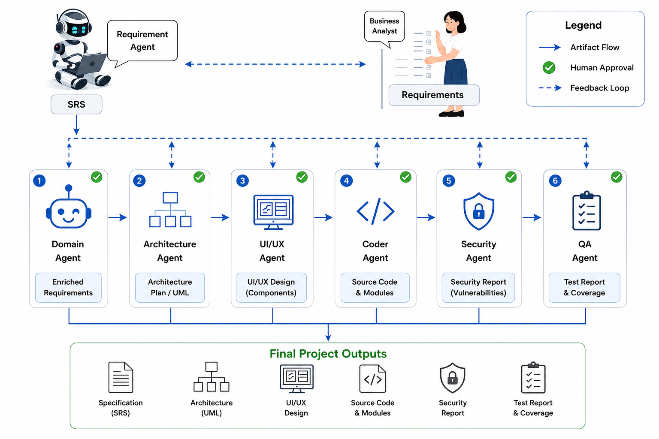
Figure 1.1: The AutoForge pipeline, showing the seven agents, their outputs, human approval and feedback loops
The project was divided into four components, one per team member. My component is the last two stages of the pipeline: the Security Agent, which scans the generated feature for vulnerabilities, and the QA Agent, which writes and runs tests against it. The other components cover requirements and orchestration, architecture and UI/UX design, and code generation. The team's common report describes the integrated system; this thesis describes my component in detail.

1.2 Individual Component Context
By the time a feature reaches my stages, it has been specified, designed, coded and verified to build and start. That verification says the code runs; it says nothing about whether the code is safe or whether it does what the acceptance criteria require. Those are the two questions my agents answer, and they matter particularly in e-commerce, where features handle passwords, personal details and orders.
The two agents share a principle: produce evidence, not opinions. The Security Agent's main findings come from deterministic analysis of the real code and its dependencies, each tied to a file, a line and a Common Weakness Enumeration (CWE) entry. The QA Agent's results come from tests actually executed in a sandbox, each with its real outcome and failure message. An LLM helps in both, by reviewing findings, reading source for issues rules cannot express, writing tests and explaining failures, but its contribution is labelled and kept separate from the deterministic evidence.
Both agents also close the loop with the Coder Agent. A reviewer can send a security report or the failing tests back as a revision, and the feature is then checked again. This makes my stages the place where problems introduced anywhere earlier in the pipeline are most likely to surface.

1.3 Problem Statement
Security checking and testing of LLM-generated code face three problems. First, the obvious tool for the job, another LLM, is not reliable on its own: it can miss real vulnerabilities, report ones that are not there, and give a different answer each time it is asked. Second, a clean result is easy to misread. A scan with no findings, or a small test suite that passes, does not show that the code is secure or correct, only that these checks found nothing. Third, generated tests are themselves generated code: when one fails, the fault may lie in the application or in the test.
The problem this thesis addresses is therefore: how can the security and QA stages of an LLM-based pipeline produce evidence about generated code that a person can trust and act on, while using LLMs where they help and being honest about what the evidence does not show?

1.4 Research Gap
Surveys of LLMs in security [3] and in software testing [4] report that LLMs are promising for both tasks but unreliable alone, and Zhu et al. recommend combining them with traditional static analysis. Coding agents such as SWE-agent [5] and OpenHands [6] are judged by whether existing tests pass, and AgentCoder [7] generates tests to guide its own coding; neither treats security scanning or test results as artefacts for a person to review before the change is accepted. Multi-agent frameworks such as ChatDev [1] and MetaGPT [2] include testing roles, but checking is performed through agent dialogue.
What is missing, as our paper puts it, is security and QA stages that produce checkable evidence: findings tied to code and to standard weakness categories, tests that are actually run, an honest separation of deterministic and model-generated results, and a person deciding what happens next.

1.5 Aim and Objectives
The aim of this work is to design, implement and evaluate the Security and QA agents of AutoForge, so that every generated feature is scanned and tested with evidence a person can review and act on.
1. O1: Build a Security Agent with deterministic pattern, secret and dependency scanning, an optional LLM layer, and a severity scheme that turns findings into a clear decision for a reviewer.
2. O2: Build a QA Agent that generates unit, integration and regression tests, the last from the approved acceptance criteria, runs them in the sandbox and explains failures.
3. O3: Connect both agents to the human review and to the Coder Agent, so that findings and failures can be sent back as revisions and the feature checked again.
4. O4: Evaluate detection accuracy, the consistency of the deterministic and AI layers, and the reliability of the generated tests, using the team's experiments and stored reports.

1.6 Research Questions
1. RQ1: How accurately does the layered Security Agent detect known vulnerabilities in generated code?
2. RQ2: How do the deterministic layers and the AI layer differ in what they find and in how consistent they are?
3. RQ3: Do the generated tests provide reliable evidence about the generated application?
4. RQ4: Does putting a person between the reports and the next step, with a loop back to the Coder Agent, lead to real fixes?

1.7 Scope, Limitations and Assumptions
The agents target the stack the Coder Agent generates: a Next.js App Router application in TypeScript with MongoDB. The Security Agent covers seven code patterns, five kinds of hardcoded secret and the npm advisory database; it is not a full static analyser and does not test the running application. The QA Agent tests modules and Route Handlers that can run without a browser; pages and React components are listed as out of scope rather than claimed as tested.
The evaluation is limited in scale. The detection experiment used a small controlled set of injected vulnerabilities, the case study three features, and the stored-report analysis two features. The results show how the agents behave, including how they fail, but not general rates.
I assume that the feature has passed the Coder Agent's verification, that the sandbox is available, and that a reviewer with some security knowledge reads the reports.

1.8 Individual Contribution
Within the team, my responsibility was the security and QA stages. My contributions are:
• the Security Agent's pattern scanner using the TypeScript compiler's syntax tree, the secret scanner, the dependency scan, the summary review layer and the AI deep source scan;
• the severity tiers, the gate decision, the security report in JSON, Markdown and PDF, the ability to mark a finding as an accepted risk, and the comparison of findings between report versions;
• the QA Agent's test discovery, unit, integration and regression test generation with fallbacks, the Jest executor, result matching and root-cause analysis;
• the links from both reports to the Coder Agent, and the chat interfaces for asking questions about a report; and
• the automated tests for these modules, the controlled vulnerability experiment, and my share of the team's evaluation and paper.

1.9 Thesis Structure
Chapter 2 reviews related work and builds a conceptual framework. Chapter 3 describes the method. Chapter 4 presents the design, and Chapter 5 covers implementation, integration and testing. Chapter 6 reports the results, including the stored reports, and Chapter 7 discusses them. Chapter 8 considers commercialisation and sustainability, and Chapter 9 concludes.

2 LITERATURE REVIEW AND RELATED WORK

2.1 Review Method and Scope
I started from the two broad surveys our paper relies on, Hou et al. [8] on LLMs for software engineering and He, Treude and Lo [9] on LLM-based multi-agent systems, and from the two surveys closest to my component: Zhu et al. [3] on LLMs and software security, and Wang et al. [4] on LLMs and software testing. From these I followed the systems most relevant to checking generated code. The sources are those of the team's paper; the aim was to place the component, not to survey the whole field.

2.2 Domain and Theoretical Foundations

2.2.1 Static analysis and weakness categories
Static analysis examines code without running it. The simplest form searches text for dangerous patterns, but text search cannot tell a call from a comment or a string that happens to contain the same word. Parsing the code into an abstract syntax tree (AST) solves this: a call to eval is a call-expression node with that name, and nothing else matches. The Common Weakness Enumeration (CWE) gives each kind of weakness a standard identifier, such as CWE-79 for cross-site scripting or CWE-798 for hardcoded credentials, which lets a finding be understood and looked up independently of the tool that produced it.

2.2.2 Secrets and dependencies
Two classes of security problem need no code analysis at all. Credentials written into source files, such as API keys or database connection strings with passwords, can be found by pattern matching over every text file. Known vulnerabilities in third-party packages are published in advisory databases, and npm audit compares a project's locked dependency versions against them. Both are fast and deterministic, and both catch problems an LLM coding agent is prone to: hardcoding a value to make something work, and adding packages without checking them.

2.2.3 LLMs for security review and testing
Zhu et al. [3] survey how LLMs are used for vulnerability detection and repair and conclude that, while LLMs can recognise issues that rules do not encode, their results vary and should be combined with static analysis rather than replace it. Wang et al. [4] survey LLM-based testing and report wide use for generating unit tests, with recurring problems: tests that do not compile, tests with wrong assertions, and low coverage of real behaviour. Both points shape my design directly.

2.2.4 Evaluating detection
A security scanner is measured by comparing its findings with the vulnerabilities actually present. A correct finding is a true positive, a reported issue that is not real is a false positive, and a real issue that is missed is a false negative. Precision, the share of findings that are real, and recall, the share of real issues found, follow from these. Measuring recall requires knowing what is present, which is why vulnerabilities are injected deliberately into a test version of the code; a clean scan of unknown code says nothing about recall.

2.2.5 Human oversight and design science
He, Treude and Lo [9] identify verifiability and human-agent collaboration as open problems, and Takerngsaksiri et al. [10] report that engineers working with an agent valued reviewing its plan and code. My work builds an artefact and evaluates it in its setting, following the design-science approach of Hevner et al. [11], which asks that the evaluation add knowledge about the design, including where it fails.

2.3 Related Research
Most coding-agent research evaluates correctness through tests. SWE-bench [12] runs a repository's own tests after an agent's change, and agents such as SWE-agent [5], OpenHands [6], HyperAgent [13] and Agentless [14] are judged this way; Agentless also generates reproduction tests to select its patches. AgentCoder [7] separates a test designer agent from the programmer agent and runs the tests in the loop. These systems show that executed tests are valuable evidence; they do not address security scanning, and their tests guide the agent rather than inform a human reviewer.
ChatDev [1] and MetaGPT [2] include reviewer and tester roles in their simulated software teams. In ChatDev, testing happens in a dialogue between agents; in MetaGPT, a QA engineer role writes and runs tests. In both, the outcome feeds back to other agents rather than producing a report for a person to approve, and security is not a separate stage.
Zhu et al.'s recommendation to combine static analysis with LLM review [3] is followed directly in the Security Agent. None of the multi-agent systems reviewed above reports security precision and recall for the code it generates; the controlled experiment in Chapter 6 measures both for the Security Agent.

2.4 Existing Systems, Products and Techniques
Table 2.1: Checking-stage properties of related systems
System | Security checking | Test evidence | Result goes to | Human gate
ChatDev [1] | N/R | Agent-run testing in dialogue | Other agents | N/R
MetaGPT [2] | N/R | QA role writes and runs tests | Other agents | N/R
AgentCoder [7] | N/R | Generated tests in the loop | Programmer agent | N/R
SWE-agent [5] | N/R | Repository tests after the run | Benchmark | N/R
AutoForge Security + QA (this work) | AST, secrets, npm audit + AI layer | Generated and executed unit, integration, regression tests | Human reviewer, then Coder Agent | Yes (security report)

In industry, static analysis tools, secret scanners and dependency auditing are standard parts of a continuous integration pipeline, and AI assistants now offer both security review and test generation. My component does not try to replace mature tools; its rule set is small. What it adds is the integration of these techniques into a human-gated agent pipeline, with labelled AI findings, a loop back to the agent that wrote the code, and an honest account of how the AI parts behave.

2.5 Gap Synthesis and Conceptual Framework
The review shows that LLM-based development systems rarely treat security as a separate stage, judge correctness through tests that guide agents rather than inform people, and seldom separate deterministic evidence from model judgement. Figure 2.1 shows the conceptual framework I used: the coded feature, its acceptance criteria and the shared sandbox go through deterministic and model-based mechanisms, controlled by severity tiers, result matching and a human decision, to reports that can drive a fix.
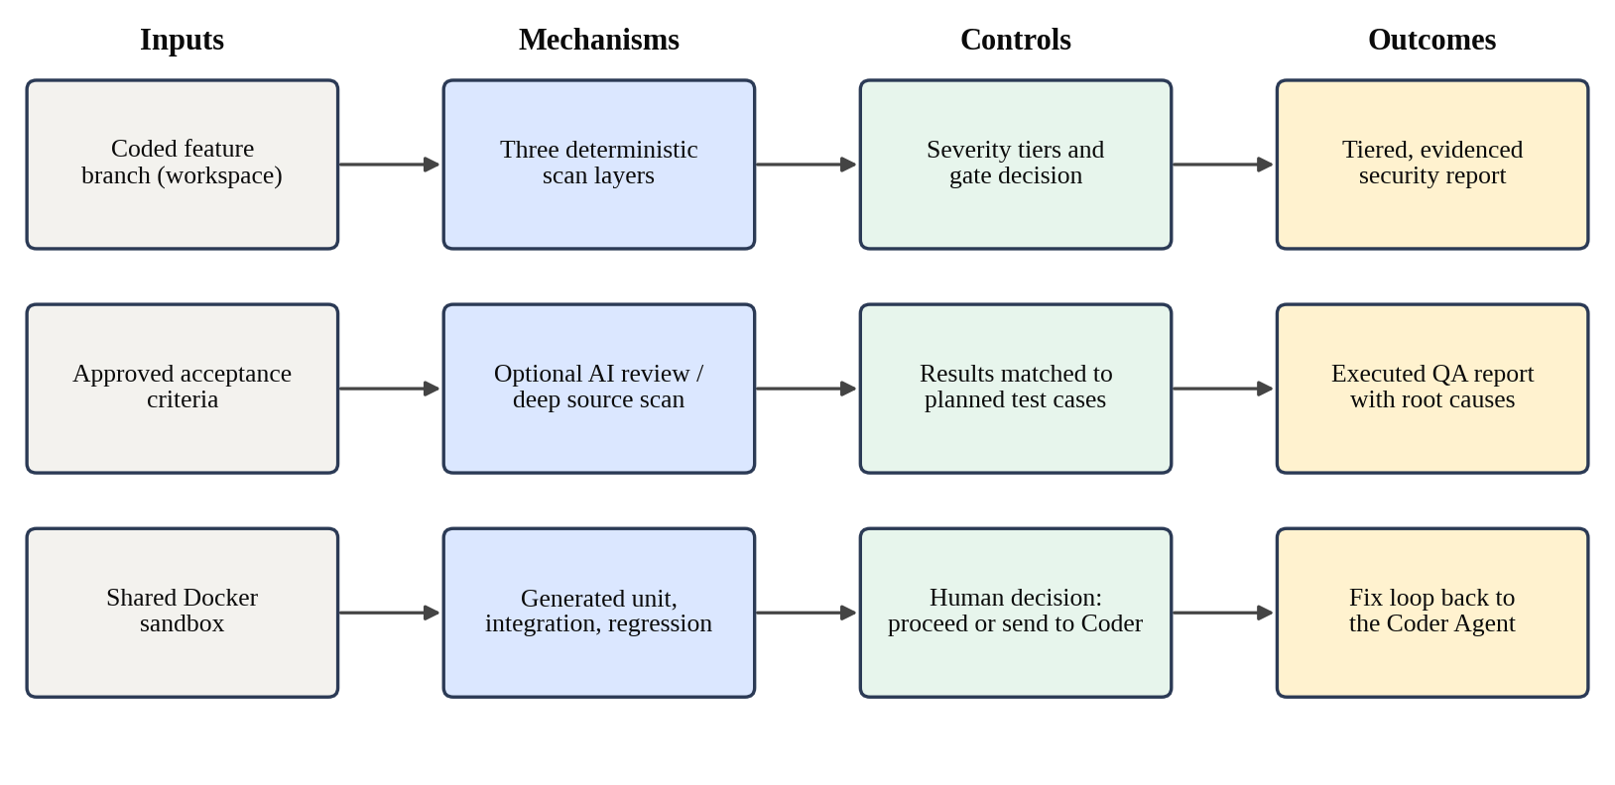
Figure 2.1: Conceptual framework for the security and QA component

3 RESEARCH METHODOLOGY

3.1 Research Design
This is design-science research in the sense of Hevner et al. [11]. I built two artefacts, the Security Agent and the QA Agent, and evaluated them inside the pipeline they serve. The evaluation combines automated tests of the agents' own logic, the team's controlled experiments, and an analysis of every security and QA report the agents stored for two features developed during the project.
Development followed build-and-evaluate cycles between July and August 2026. Several design changes came from specific failures: a pattern rule that could never fire because of how the syntax-tree helper names method calls, false-positive secret findings in the local environment file, and a test runner whose output could not be matched to individual tests. I report these as findings, because they explain the design.

3.2 Data, Participants and Study Materials
Table 3.1: Study materials
Material | Source | Used for
Controlled vulnerability set | Team experiment reported in the paper | Precision and recall (RQ1)
Item Listing, Authentication, Shopping Cart | Team case study | Security findings and QA results per feature
Expanded QA run | Team experiment reported in the paper | Tests by category
Login and Signup: 19 security and 7 QA reports | Finodil project, stored artefacts | Layer behaviour, consistency, fix loop (RQ2-RQ4)
Add & List Items: 3 security and 1 QA report | Retail Store project, stored artefacts | False positives, test reliability (RQ2, RQ3)

The default model was qwen3-coder through Ollama. No external participants took part, and no personal data was collected. Some stored reports quote credentials that appeared in generated code; these are not reproduced in this thesis.

3.3 Experimental and Study Procedure
Controlled detection experiment. Because the case-study features produced few or no findings, which cannot establish recall, the team injected known vulnerabilities into isolated versions of a generated application, ran the Security Agent, and classified each finding as a true positive, a false positive or, for injected issues not found, a false negative.
Seeded feature. To observe the layers on known vulnerabilities in our own stored data, five vulnerabilities were deliberately introduced into the Login and Signup feature of the Finodil project in a single commit on 22 August 2026, whose message records them as authorised test vulnerabilities for verifying the Security Agent. Table 3.2 lists them. Every security report produced while this code was in place was analysed, and so were the reports after the Coder Agent's fixes.
Table 3.2: Vulnerabilities seeded into the Login and Signup feature
ID | Vulnerability | Location | CWE
V1 | MongoDB connection string with a hardcoded credential as a fallback | lib/mongodb.ts | CWE-798
V2 | Error message rendered with dangerouslySetInnerHTML | Login and signup page | CWE-79
V3 | Client-supplied filter object merged directly into the login query | Login route | CWE-943
V4 | bcrypt cost factor of 1 when hashing passwords | Signup route | CWE-916
V5 | Plaintext password written to the log on login | Login route | CWE-532

Case study. Each of three features went through all seven stages, and the security findings and QA results were recorded per feature. An expanded QA run then classified tests into unit, regression and integration categories and recorded executed, passed and failed counts.
Stored-report analysis. For the two development features I examined every stored report: for security, each finding's layer, rule, severity, CWE and location, and how the findings changed between versions; for QA, each test's category, outcome, failure message and root cause. Where the same code was scanned more than once, I compared the results to measure consistency.
Component testing. The scanners, severity mapping, deep-scan batching, result matching, Jest result parsing, generation fallbacks and routes were tested against fixtures, with the Node helper, the sandbox and the model replaced by stubs where needed.

3.4 Measures and Evaluation Metrics
Table 3.3: Measures used for each research question
RQ | Measure | How it is obtained
RQ1 | True positives, false positives, false negatives, precision, recall | Controlled injection experiment
RQ2 | Findings per layer; variation across repeated scans; false positives and mislabelled CWEs | Stored security reports
RQ3 | Tests generated, passed, failed, skipped; cause of each failure (application or test) | Stored QA reports; expanded QA run
RQ4 | Findings resolved after a revision; revisions requested | Report versions; Coder Agent revision artefacts

Precision is TP / (TP + FP) and recall is TP / (TP + FN).

3.5 Data Analysis
The analysis is descriptive. The detection experiment is small, so precision and recall are reported with their underlying counts. For the stored reports, I report counts and individual cases, and I separate findings and failures that reflect a real problem in the application from those caused by the check itself, because the two lead to opposite actions.

3.6 Ethics, Privacy, Security and Responsible AI
Security tooling handles sensitive material. The secret scanner reports where a credential appears and what kind it is, and the reports are stored with the project's other artefacts; this thesis does not reproduce any credential. The secret scanner deliberately skips the gitignored local environment files, where the project is meant to keep its real secrets, so that the correct place for a secret is not reported as a leak. Dependency auditing and test execution run inside the shared Docker sandbox, never on the host.
The AI layers are labelled as such in every report, kept separate from deterministic findings, and allowed to fail without affecting them. A reviewer can mark a finding as an accepted risk instead of fixing it, which is recorded rather than hidden. No security report is acted on automatically: a person decides whether to proceed or to send it to the Coder Agent.

3.7 Reproducibility and Research Artefacts
Table 3.4: Configuration parameters of the component
Parameter | Value
Default LLM | qwen3-coder via Ollama
Pattern rules / secret rules | 7 / 5
Dependency scan | npm audit --json --offline, 60 s timeout
Deep scan batch size | Up to 12,000 characters of source per call
Deep scan concurrency | Up to 3 batches at a time
Test framework | Jest 29 with Babel TypeScript preset
Severity tiers | Critical, Moderate, Warning

All code and tests are in the team's repository, and every report is a numbered artefact in JSON and Markdown, with a PDF on request. The deterministic layers give the same result for the same code; the AI layers and the generated tests do not, which is itself one of the findings of Chapter 6.

4 PRODUCT AND SOLUTION DESIGN

4.1 Requirements
The requirements came from the team's pipeline objectives, from what a reviewer needs in order to act on a report, and from problems found in real runs. Table 4.1 lists the functional requirements and Table 4.2 the non-functional ones.
Table 4.1: Functional requirements of the component
ID | Requirement
C4-FR-01 | Scan the generated project for dangerous code patterns using a real syntax tree
C4-FR-02 | Scan text files for hardcoded secrets, excluding git-ignored local environment files
C4-FR-03 | Audit the project's dependencies against published advisories
C4-FR-04 | Optionally add model findings, either by reviewing the deterministic findings or by reading the source
C4-FR-05 | Map every finding to Critical, Moderate or Warning and derive a pass, review or fail decision
C4-FR-06 | Give every finding a location, CWE, root cause and recommendation
C4-FR-07 | Let the reviewer proceed or send the findings to the Coder Agent, then re-scan after the fix
C4-FR-08 | Let the reviewer mark individual findings as skipped
C4-FR-09 | Discover unit and integration test targets, and list untestable files explicitly
C4-FR-10 | Generate unit, integration and one regression test per approved acceptance criterion
C4-FR-11 | Run the tests in the sandbox and record each test's real result
C4-FR-12 | Explain why failed tests failed
C4-FR-13 | Answer the reviewer's questions about a report in a chat

Table 4.2: Non-functional requirements of the component
ID | Quality | Requirement
C4-NFR-01 | Groundedness | Deterministic findings must not depend on a model; model findings must be labelled
C4-NFR-02 | Robustness | A failed or unparseable model response must never fail the scan or the test run
C4-NFR-03 | Honesty | What was not checked or not tested must be stated in the report
C4-NFR-04 | Safety | Dependency audits and tests must run in the sandbox, not on the host
C4-NFR-05 | Consistency | Severity must be expressed in one fixed vocabulary across all layers
C4-NFR-06 | Testability | Rule matching and parsing must be testable without Node or a model
C4-NFR-07 | Responsiveness | Long scans and test runs must stream progress to the interface

4.2 Component Architecture within the Complete Solution
Figure 4.1 places the component in the complete system. Both agents run after the Coder Agent, against the same project workspace, and both use the shared Docker sandbox for anything that executes code. The Security Agent's findings, and the QA Agent's failing tests, can travel back to the Coder Agent as a revision request, which lets a later stage send work back to an earlier one without starting that stage again from scratch.
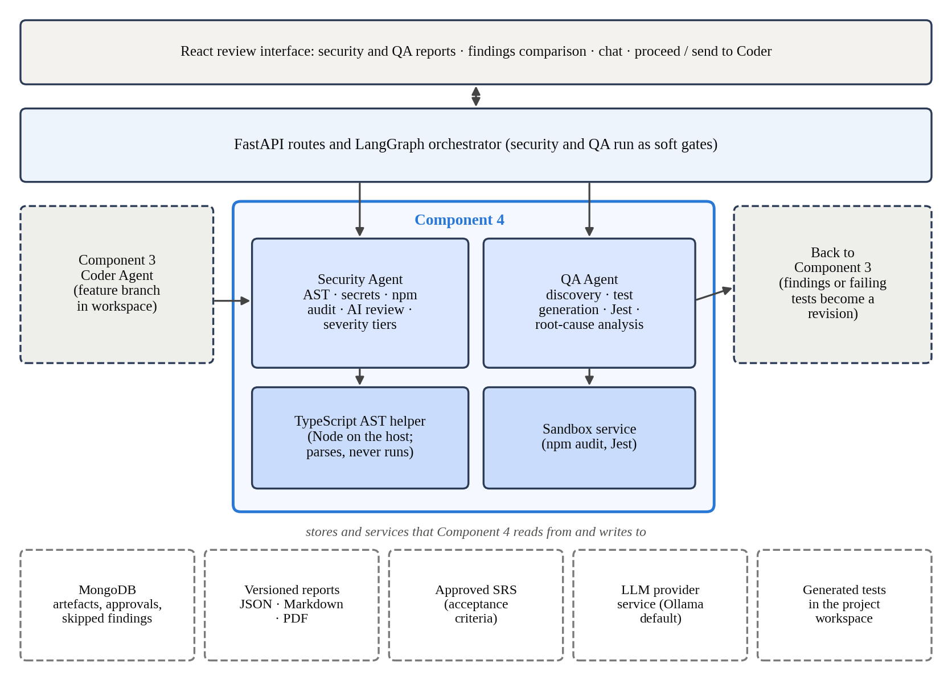
Figure 4.1: The component's place in the complete AutoForge architecture
In the orchestration graph, the security and QA stages run without a graph interrupt: the pipeline does not stop and wait at them. They are not unreviewed, however. The security report is saved as pending and must be approved by a person, and approving it opens the choice between proceeding and sending the findings to the Coder Agent. The QA report is saved as approved and reviewed by a person afterwards. Our research paper describes every stage as pausing for a decision; this difference is discussed in Section 7.5.

4.3 Design Alternatives and Decisions
Table 4.3: Main design decisions
Decision | Alternative | Reason for the choice
Deterministic layers as the core | Ask an LLM to review the code | Stable, explainable findings; follows the hybrid approach recommended in the literature
AST-based pattern scan | Regular expressions over the source | No false matches in comments or strings; a call is a real call
Two optional model layers | No model layer | Model layers catch logic flaws such as injection that fixed rules miss
Three fixed severity tiers | Pass through each layer's own severity words | One vocabulary for the report, the counts and the interface
Gate decision as advice | Block the pipeline on Critical findings | Heuristic findings can be wrong; a person decides, with a fix loop available
Jest with --json output | Node's built-in test runner | Real per-test structured results without a custom parser
Tests from real source | Tests from signatures only | The model can see what the code actually does and imports
Pages listed as out of scope | Test pages without a browser, or ignore them | Honest about what a DOM-less runner can check

Two of these decisions differ from the description in our paper, because the implementation has moved on since. The paper describes a gate in which a critical or high finding fails the security stage; in the implementation the decision is advice to the reviewer, because the fix loop gives a better response to a failing scan than stopping the pipeline. The paper also describes the QA Agent as using Node's built-in test runner and focusing on lib/ and models/ files; the implementation now uses Jest and also writes integration tests for API route handlers.

4.4 Detailed Design

4.4.1 Deterministic security layers
Figure 4.2 shows the security pipeline. The pattern scan parses every JavaScript and TypeScript file with the TypeScript compiler and walks the syntax tree, matching seven rules, listed in Appendix A: eval, the Function constructor, child_process exec, document.write, dangerouslySetInnerHTML, dynamic property access keyed by request-like names such as sort or field, and Math.random. Each rule carries a severity, a CWE, a message, a root-cause template and a recommendation. Two events for the same rule, file and line are reported once.
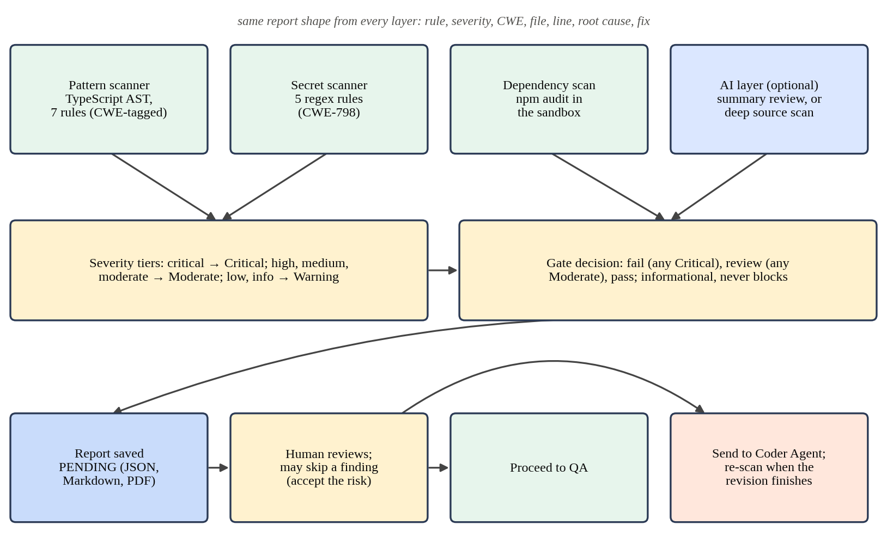
Figure 4.2: Security Agent pipeline
The secret scan uses five regular-expression rules, for AWS access keys, generic API keys and tokens, private key blocks, MongoDB connection strings with an embedded password, and literal JSON Web Tokens, all at critical severity. It reads all text-like files, including .env and .env.example, because secrets leak into configuration as often as into code. It skips files matching .env*.local: these are git-ignored and are where AutoForge deliberately stores a project's real database connection, so flagging them was a false positive that could never lead to a leak. The dependency scan runs npm audit with JSON output inside the sandbox and turns each reported package into a finding.

4.4.2 Model layers
The standard scan adds a review layer: the model is shown a compact summary of the deterministic findings, never the source, and asked to propose further, clearly grounded findings in a fixed JSON shape. The AI deep scan replaces this with a layer that reads the real source. Files are sorted by path, so that related files fall together, grouped into batches under a character limit, and scanned concurrently, with each finding given a sequential identifier. Both layers follow the same rule: a model call that fails, or returns something that cannot be parsed, contributes no findings and a status note saying why. It never fails the scan, and it never changes the deterministic findings.

4.4.3 Severity tiers and the gate decision
The layers use two severity vocabularies: the scanners and model layers use critical, high, medium and low, while npm audit uses critical, high, moderate, low and info. A single function maps both onto the three tiers shown in Table 4.4, and every count, badge and decision reads the tier through that function. An unknown severity word, for example one a model invents, maps to Warning rather than causing an error.
Table 4.4: Severity mapping and gate decision
Raw severity | Tier | Gate decision
critical | Critical | Fail if any Critical finding
high, medium, moderate | Moderate | Review if no Critical and any Moderate
low, info, unknown | Warning | Pass if nothing above Warning

4.4.4 Reports, decisions and the fix loop
Each report records the scan type, the gate decision, counts per tier, every finding with its location, CWE, root cause and recommendation, the dependency audit summary and the status of the model layer. It is saved in JSON and Markdown, can be exported as a PDF, and is pending until a person approves it. On approval, the reviewer chooses to proceed or to send the report to the Coder Agent. Sending it starts a Coder Agent revision whose request is the list of findings; when that revision finishes, the Security Agent runs again automatically and produces a new pending report. The loop continues until the reviewer proceeds or the scan comes back clean. A reviewer can also mark individual findings as skipped, for example a known false positive, and ask questions about the report in a chat that has the report as its context.

4.4.5 Test discovery and generation
Figure 4.3 shows the QA pipeline. Discovery finds three kinds of target. Unit targets are TypeScript files under lib/ and models/ with at least one export. Integration targets are API route handlers together with the local model and library files they import, so that a test can exercise the real path from request to handler to data. Regression targets are the feature's approved acceptance criteria, one test each. React pages and components are discovered too, but only so that they can be listed in the report as out of scope.
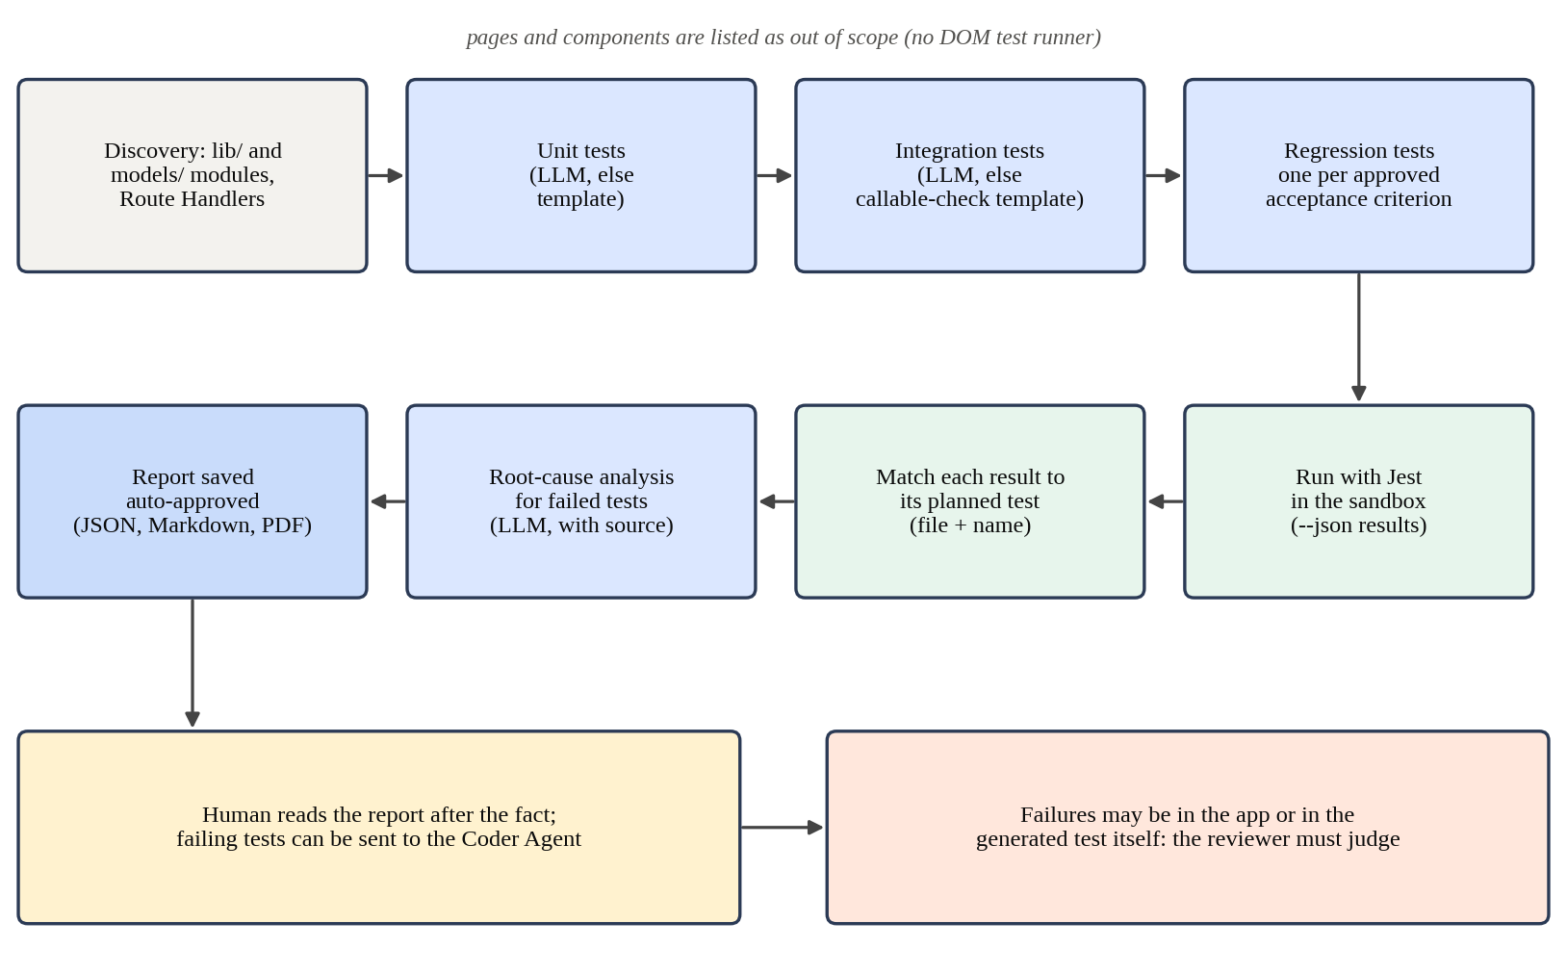
Figure 4.3: QA Agent pipeline
For each target the model receives the real source and returns two parts: JSON metadata describing each test case, its target, inputs and expected behaviour, followed by a fixed marker and the test file itself. Splitting on a plain marker avoids the escaping errors that come from putting a code file inside JSON. Tests that use skip, todo, each or concurrent are rejected, because they break the one-to-one link between planned and executed tests, and the attempt is retried with the reason, up to three times. If every attempt fails, a deterministic fallback writes a minimal test instead: that the module or handler can be loaded and called without crashing. Fallback tests are labelled as such in the report.

4.4.6 Execution, matching and analysis
Before the first run, the agent adds Jest and its Babel configuration to the project's development dependencies and installs them once. Tests run with Jest's JSON output in the sandbox. Each result is matched back to the test case that planned it by file and name, with a positional fallback within the same file when the model renamed a test. A planned test with no result is reported as failed with an explicit note, never as passed or silently dropped, and every result is either passed or failed. If Jest produces no results at all for the planned tests, the report records an environment failure instead of a list of test failures. Otherwise, one batched model call analyses all failures together and adds a root cause and a recommendation to each.

4.5 Standards and Professional Practice
Findings are classified with CWE identifiers, so that each one names a recognised weakness class and links to public guidance. The combination of static analysis with model review follows the recommendation of Zhu et al. [3], and the three test categories follow common practice: unit tests for single modules, integration tests across modules, and regression tests tied to acceptance criteria so that later changes can be checked against the original requirement.
Dependency audits and test runs execute in a container, never on the host. Reports state what was not examined, which is ordinary professional practice for security and test reports, and the gate decision is presented as a recommendation for a person, not as an automatic verdict.

5 IMPLEMENTATION

5.1 Development Environment and Technology Stack
Both agents are Python packages inside the team's FastAPI backend. The code they examine is TypeScript, so parts of the work run in Node.js. Table 5.1 lists the main technologies.
Table 5.1: Technology stack used by the component
Concern | Technology | Why it was used
Agent backend | Python, FastAPI, Pydantic | Typed reports and streaming progress
Syntax-tree scan | TypeScript compiler API via a small Node script | A real parse of TS and TSX, including JSX attributes
Secret scan | Python regular expressions | Works on any text file, not only code
Dependency audit | npm audit in the Docker sandbox | Uses the project's own lock file; isolated from the host
Model layers | qwen3-coder via Ollama (provider service) | Local model; any configured provider can be used
Test framework | Jest with babel-jest | Structured per-test JSON results
Reports | JSON, Markdown, PDF builder | Machine-readable and human-readable forms of the same report
Frontend | React 19, Vite, Tailwind CSS 4 | Report views, decision dialog and report chat
Testing | pytest | Fixture-based tests with recorded Node and model outputs

5.2 Implementation of the Core Modules
Table 5.2: Main modules of the component
Module | Lines | Responsibility
security_agent/agent.py | 507 | Standard and deep scan flows, report building, review layer, chat
security_agent/scanners.py | 366 | AST pattern scan, secret scan, dependency audit
security_agent/deep_scan.py | 349 | Source-reading scan in concurrent batches
security_agent/severity.py | 60 | Severity tiers, counts and gate decision
security_agent/prompt.py, schemas.py, pdf_builder.py | 361 | Prompts, report schema, PDF export
qa_agent/agent.py | 621 | Run flow, result matching, root-cause step, report, chat
qa_agent/generator.py | 408 | LLM generation with retries and deterministic fallbacks
qa_agent/executor.py | 194 | Jest setup, sandboxed run, result parsing
qa_agent/discovery.py | 144 | Unit, integration and out-of-scope discovery
qa_agent/prompt.py, schemas.py, pdf_builder.py | 446 | Prompts, report schema, PDF export

5.2.1 Security scanners
The pattern scan writes a short Node script that uses the TypeScript compiler to parse a file and emit an event for every call, constructor, JSX attribute and bracket property access, with its name and line. The Python side matches these events against the rule table. The script resolves TypeScript from the scanned project's own dependencies, which every generated project already has, rather than from the backend's. This step only parses code; it never executes it.
Testing the rule matching found a real bug. The rule for Math.random originally matched the name Math, but the syntax-tree script reports only the final part of a property call, random, so the rule could never fire. The rule now matches random, in the same way the other method rules match the method name. The tests for the scanner feed recorded events into the matcher, which is how this was caught without needing Node in the test environment.
The secret scan walks the project, skipping folders such as node_modules and .next, which in a built project contain tens of thousands of files, and applies the five rules line by line. The dependency scan runs npm audit with JSON output through the sandbox service. As implemented, the command includes the --offline flag, and the report's audit_ran_offline field is set from a fixed string rather than from the command actually run. Chapter 6 discusses what this means for the dependency results.

5.2.2 Model layers and reports
The review layer sends the model a numbered summary of the deterministic findings and parses its answer against a schema. Responses wrapped in Markdown fences are still parsed; malformed ones, missing fields and an unreachable provider all produce an empty list and a status note. The deep scan reads every scannable file, groups the files into batches under a character limit, and runs the batches concurrently with a bounded number of simultaneous calls; a failed batch is logged and contributes nothing. Concurrency was added after a scan of a multi-file project turned out to need ten to thirty sequential model calls.
The report builder merges the deterministic and model findings, computes the tier counts and gate decision, and saves the JSON and Markdown versions through the shared artefact service with a pending status. A streaming version of the deep scan reports progress batch by batch to the interface.

5.2.3 QA discovery, generation and execution
Discovery strips comments before looking for exports, so that a commented-out function is not treated as a test target, and resolves imports such as @/models/Item to real files so that an integration test can be given the source of everything a route handler uses. Generated test files are written to a generated_tests folder in the workspace, which is cleared at the start of each run so that a test for a deleted module is never run again.
The executor's Jest configuration names the Babel configuration file explicitly. Without it, a live run showed babel-jest silently searching for its own configuration and failing to transform TypeScript. Jest writes its results to a JSON file, which the parser reads; Jest's own pending and todo statuses cannot occur, because the constructs that produce them are rejected at generation time.

5.2.4 Interface support
On the frontend, the component provides report views with colour-coded tier badges that also carry text labels, a decision dialog with the proceed and send-to-Coder options, controls to mark a finding as skipped, a button to start an AI deep scan, and a chat for each agent. Reviewers can also download a feature's code together with its QA report.

5.3 Integration with the Complete Solution
The component integrates with the Coder Agent in two directions. Forwards, it reads the same workspace the Coder Agent wrote and runs everything that executes through the same sandbox service. Backwards, the send-to-Coder action turns a security report into a Coder Agent revision, and the Coder Agent's verifier includes an informational check that every file named in the findings was touched by the fix. With the requirement stage, the QA Agent reads the approved acceptance criteria to write regression tests.
In the orchestrator, the security and QA nodes call the agents and advance without a graph interrupt. The approval service handles the security report's pending status like any other artefact, and the approval hook triggers the decision dialog.

5.4 Testing and Quality Assurance
Table 5.3: Automated tests for the component
Area | Test files | Test functions
Security Agent: scanners, layers, reports, routes, skip | 7 | 96
QA Agent: generation, execution, matching, reports, routes | 10 | 99
Total | 17 | 195

The tests concentrate on the parts that must never fail silently: the severity mapping for every raw word including unknown ones, the gate decision, every model-layer failure mode, the saving of the security report as pending rather than approved, the rejection of forbidden Jest constructs, the deterministic fallbacks, matching when the model renames a test, and the detection of an environment failure when Jest produces no results.
The last recorded run of the backend suite, on 31 August 2026, collected 239 test cases whose names refer to the security or QA stages. The failures recorded in that run's cache for this component all belong to tests that have since been renamed or removed, including stub tests from before the agents were implemented, so no current test is recorded as failing.

5.5 Deployment and Operation
The component needs Node.js on the backend machine for the syntax-tree scan and Docker for the sandbox. Jest is added to each generated project the first time the QA Agent runs and is shipped with the project when it is downloaded. Reports are stored with the other artefacts and persist across restarts.

6 RESULTS AND EVALUATION
This chapter reports the results in the order of the research questions, after summarising what the automated tests established. It draws on three sources: the team's evaluation in our research paper, the Login and Signup feature in which five vulnerabilities were deliberately seeded, and the stored security and QA reports from two development projects. The stored reports show weaknesses as well as strengths, and I report both.

6.1 Component-Level Test Results
Table 6.1: Key behaviours confirmed by automated tests
Behaviour | Test file | Result
Every raw severity word, including unknown ones, maps to the right tier | security_agent | Pass
The gate decision follows the tier counts | security_agent | Pass
Malformed, fenced or missing model output, or an unreachable provider, never fails the scan | security_agent | Pass
The security report is saved as pending, not approved | security_agent | Pass
Each AST rule fires on its construct; duplicate events are reported once | security_ast_scanner | Pass
A failed deep-scan batch is skipped without aborting the scan | security_deep_scan | Pass
Findings can be marked and unmarked as skipped | security_finding_skip | Pass
Forbidden Jest constructs are rejected and fallbacks are used after failed attempts | qa_generator_fallback | Pass
Results match planned tests by file and name, with a positional fallback | qa_agent_matching | Pass
No Jest results for planned tests is reported as an environment failure | qa_environment_failure | Pass

6.2 Experimental Results

6.2.1 Detection of known vulnerabilities (RQ1)
Our research paper reports the team's security evaluation on a controlled vulnerability set: 7 true positives, 1 false positive and 2 false negatives, a precision of 87.5% and a recall of 77.8%. To look at how the individual layers contribute, I analysed every report produced while the five vulnerabilities in Table 3.2 were present in the Login and Signup feature: three standard scans and four AI deep scans. Table 6.2 shows which vulnerabilities each layer found.
Table 6.2: Detection of the seeded vulnerabilities by layer
Seeded vulnerability | Deterministic layers (7 reports) | Review layer (3 standard scans) | AI deep scan (4 reports)
V1 Hardcoded credential (CWE-798) | 7 of 7 | Not as a new finding | 4 of 4
V2 Raw HTML rendering (CWE-79) | 7 of 7 | Not as a new finding | 4 of 4
V3 NoSQL injection (CWE-943) | 0 of 7 | 0 of 3 | 4 of 4
V4 Weak bcrypt cost (CWE-916) | 0 of 7 | 0 of 3 | 4 of 4
V5 Password in log (CWE-532) | 0 of 7 | 0 of 3 | 4 of 4
False or mislabelled findings | None | 1 per report (3 in total) | 1 in 3 of the 4 reports

The deterministic layers behaved exactly as designed. They found the two vulnerabilities that match a rule, the hardcoded connection string and the raw HTML attribute, in every report, at the right file and line, with no false findings. They did not find the other three, because none of them is a single dangerous construct: an injection depends on how a request value reaches a query, a weak hash on the value of an argument, and a leak on what is being logged.
The review layer, which sees only a summary of the deterministic findings, added one finding to each standard scan, and none of the three was useful. Each pointed at a location the deterministic layers had already reported, but with the wrong vulnerability class: the raw HTML finding was relabelled as an insecure direct object reference, and in two later reports a finding was labelled as SQL injection (CWE-89), first for the hardcoded connection string and then for the raw HTML attribute. The project does not use SQL at all.
The AI deep scan, which reads the source, found all five vulnerabilities in all four reports, with correct files and CWE classes. It also reported, in three of the four, that passwords were stored in plain text. They were not: the code hashed them with bcrypt, at the deliberately weak cost of 1, which the scan had already reported correctly as V4. For RQ1, then, the deterministic layers are precise but narrow, the deep scan has much wider reach at the cost of occasional false findings, and the summary review layer added noise rather than detection.
The dependency layer reported no vulnerable packages in any stored report. Because the audit command runs with the --offline flag, npm may not have been able to consult the advisory data at all, so these zero results cannot be read as evidence that the dependencies are safe.

6.2.2 Consistency between scans (RQ2)
Figure 6.1 shows the findings in all nineteen security reports of the Login and Signup feature, split by the layer that produced them. From the project's git history, reports 2 to 8 scanned the same seeded code, reports 9 to 12 the code after the first fix, and reports 13 to 19 the same code after the second fix.
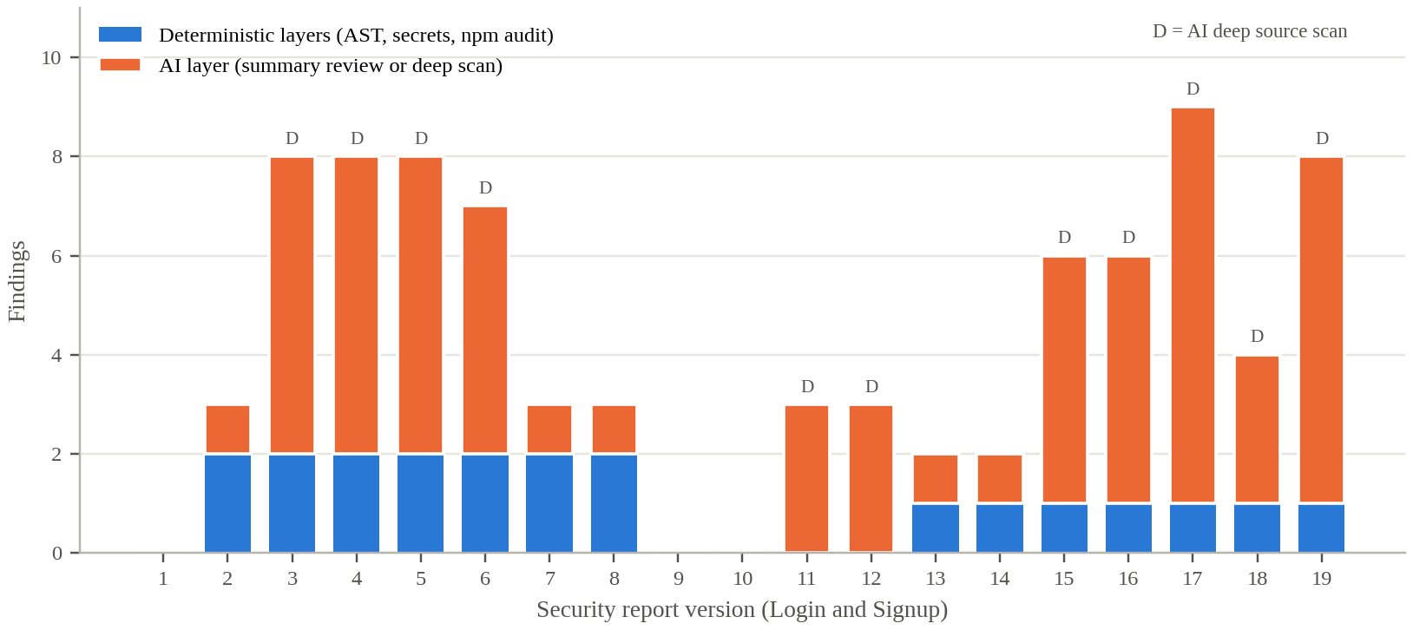
Figure 6.1: Findings per security report for the Login and Signup feature, by producing layer
On the seeded code, the deep scan was consistent about what mattered: the five seeded vulnerabilities appeared in all four reports. It was less consistent about the rest. The false plaintext-password finding came and went, and the weak-hashing finding was Critical in three reports and Moderate in the fourth. On the fixed code, five deep scans of identical code reported 6, 6, 9, 4 and 8 findings, one of them with a Critical finding and four without. The plaintext-password claim reappeared in two of them, once at high severity and once at critical, although the fixed code hashes passwords with a cost factor of 12. The standard scans of the same code, by contrast, reported the same two findings each time.
The retail store feature shows the same pattern on a smaller scale. Two deep scans run four minutes apart on the same code returned five and six findings that barely overlapped. Some were reasonable, such as an image URL accepted without validation, which matters because the Coder Agent had chosen to accept image URLs. Others were not, such as a claim of insecure deserialisation simply because the code uses Mongoose, a "hardcoded secret" for reading an environment variable, and four copies of a logging finding filed under CWE-319, which concerns cleartext transmission. For RQ2, the deterministic layers are fully repeatable and the deep scan is not: a reviewer should treat a single deep-scan report as a list of leads, not as a measurement.

6.2.3 Evidence from generated tests (RQ3)
Our research paper reports the team's QA evaluation: 2 of 2 tests passing for Item Listing, 14 of 16 for Authentication and 18 of 20 for Shopping Cart, and an expanded evaluation of 60 tests with 54 passing and 79% coverage. The QA Agent as implemented does not itself measure code coverage, so the coverage figures come from that evaluation, not from the agent's reports.
The eight QA reports stored in the development projects give a much less favourable picture, and it is important to report it. Table 6.3 summarises all 46 test cases in them.
Table 6.3: Outcome of all test cases in the stored QA reports
Generated by | Passed | Failed | Not run (early versions)
Model (LLM) | 0 | 15 | 22
Deterministic fallback | 5 | 0 | 4
Total | 5 | 15 | 26

No model-generated test in the stored reports passed, and in every case I examined the failure was in the test, not in the feature. In the retail store report, all five regression tests failed with "POST is not defined" or "GET is not defined": they called the route handlers without importing them. The same error appears in the last Login and Signup report. In the first Login and Signup report, six unit tests failed because they read a property of the Mongoose schema that does not exist. The 26 tests marked as not run come from the earlier reports, in which test files that failed to load produced no results for their planned tests; the agent then reported such tests as skipped, and it now reports them as failed. The five passing tests were all minimal fallback checks that a module can be loaded and called.
Two parts of the design did work well. The root-cause analysis correctly identified the missing import in every regression failure, so a reviewer reading the report would see that the tests, not the feature, were at fault. And one failing unit test in the first Login and Signup report did reveal a real problem: it expected the connection helper to use the test connection string, and received the hardcoded fallback credential, which was the seeded vulnerability V1. For RQ3, the execution, matching and analysis machinery produces honest results, but in the stored runs the model-generated tests were not good enough to serve as evidence about the feature. The difference from the paper's results remains to be explained, and I return to it in Chapter 7.

6.2.4 The fix loop (RQ4)
The Login and Signup feature went through the full loop twice. The standard scans of the seeded code reported V1 and V2, and the reviewer sent them to the Coder Agent. The resulting revision removed both, and the next two standard scans passed with no findings. The deep scans run immediately afterwards still reported V3, V4 and V5, which the standard scan cannot see, and a second revision, whose plan states that it addresses the injection in the login route, removed them: the fixed code restricts the filter to an allow-list, uses a bcrypt cost factor of 12 and no longer logs the password.
The fix itself produced a new finding. The allow-list loop indexes the filter object by a variable named key, which matches the dynamic property access rule, so every later standard scan reported a Moderate finding on exactly the code that fixed the injection. The deep scans also kept reporting a NoSQL injection risk in the same route. That is arguably still valid: the allow-list admits the email field, so a caller can still pass an object with a query operator in place of an email string. For RQ4, the loop did remove all five seeded vulnerabilities in their original form within two revisions, but the reports that followed needed a person to tell a residual risk from a false alarm.

6.3 Stakeholder and User Validation
No security professionals, testers or businesses outside the project team used the component. Reviews were made within the team, by people who knew which vulnerabilities had been seeded. A reviewer who did not know would face the harder task of judging deep-scan findings on their own, which makes the inconsistency in Section 6.2.2 more significant.
Team use did shape the design. The proceed or send-to-Coder choice, the AI deep scan, concurrent batching, the explanation of why each test failed, and the rule that every test is reported as passed or failed were added at team members' request while using the agents on real features.
[Student to complete: add any feedback from the supervisor, co-supervisor or panel on the security or QA reports, with dates.]

6.4 Integration and Performance Results
Both agents ran in every pipeline run of the team's evaluation. The Security Agent reported 0, 1 and 1 issues for Item Listing, Authentication and Shopping Cart. With human gates switched off, the team recorded 4 security issues and 5 escaped defects, against 1 and 1 with gates on. Table 6.4 shows the cost of each run; the logs do not separate the time of each stage.
Table 6.4: Execution performance of the full pipeline
Run | Total time (min) | LLM calls | Retries | Tokens
Item Listing | 36.4 | 24 | 4 | 31,800
Authentication | 52.7 | 31 | 6 | 42,600
Shopping Cart | 56.8 | 34 | 7 | 47,900
Baseline | 31.2 | 18 | 3 | 25,400

The stored reports give a rough idea of the security stage's own cost. A standard scan and a deep scan of the same code were typically a few minutes apart, and consecutive deep scans of the retail store feature were four minutes apart, so a scan takes minutes rather than tens of minutes. The QA stage is slower, because its first run installs Jest and every run executes the suite in the sandbox.

6.5 Summary of Findings
Table 6.5: Summary of findings by research question
RQ | Finding | Strength of evidence
RQ1 | Deterministic layers found 2 of 5 seeded issues every time with no false findings; the deep scan found 5 of 5 every time, with a false finding in 3 of 4 reports; the review layer added only mislabelled duplicates | One seeded feature; paper's controlled set
RQ2 | Deterministic results were identical across scans; deep-scan results on identical code varied from 4 to 9 findings | Nineteen reports; git history
RQ3 | Execution and failure analysis were honest, but no model-generated test passed in the stored runs, all because of test defects | Eight stored reports; paper's case study
RQ4 | Two fix rounds removed all five seeded issues; the fix triggered a new rule finding and left a partly valid injection risk | One feature's full loop

7 DISCUSSION

7.1 Interpretation of the Results
The security results support the hybrid design, but not in the way I expected at the start. I expected the model layer to be a modest addition to a strong deterministic core. In practice, the deterministic core was perfectly reliable but narrow, finding two of the five seeded vulnerabilities, while the source-reading deep scan found all five every time. On detection alone, the deep scan was the more useful layer.
Its weakness was consistency. The same code produced between four and nine findings depending on the run, a plainly false finding came and went, and severities shifted. A reviewer who saw one report could not tell which findings were stable. This is precisely where the deterministic layers earn their place: they give the reviewer findings that do not change, can be traced to a rule, and are never invented. The two kinds of layer answer different needs, which is the point Zhu et al. [3] make about combining them.
The summary review layer, on the other hand, did not justify itself in these runs. Shown only a summary, it could do little but restate the deterministic findings, and it did so with the wrong vulnerability class. A model given less context produced worse output, which argues for giving any model layer the real code or nothing.
The QA results are the most sobering part of this work. The machinery around the tests, execution in the sandbox, matching, honest statuses and root-cause analysis, worked as designed and told the reviewer the truth: that the tests were broken. But the tests themselves, in the stored runs, never provided passing evidence about a feature. The most common defect, calling a route handler without importing it, is simple and repeated, which suggests a fixable problem in the regression prompt or a missing deterministic check rather than a fundamental limit.
The gap between these stored runs and the QA results reported in our paper needs to be stated plainly. The paper's results come from the team's case study on a different project, and some of its figures, such as code coverage, are not produced by the agent as implemented. I cannot reconcile the two from the stored artefacts alone. The responsible reading is that the QA Agent's test quality varies strongly between runs, and that the paper's QA figures should be repeated with the current implementation before they are relied on.

7.2 Comparison with Related Work
Zhu et al. [3] recommend combining static analysis with LLM review; my results give a small, concrete picture of what each half contributes and costs. Wang et al. [4] warn that generated tests often fail to run or check the wrong thing; the stored QA reports are a direct example, and the root-cause step shows one way to keep such failures from misleading a reviewer. AgentCoder [7] puts test execution inside the generation loop, so that a broken test is fixed before anyone sees it; the QA Agent retries only for forbidden constructs, not for tests that fail because of their own errors, which is the most obvious lesson to take from it.
Compared with ChatDev [1] and MetaGPT [2], whose reviewer and QA roles are agents talking to agents, my component reports to a person and lets that person send findings back for a fix. The fix loop in Section 6.2.4 is consistent with the value Takerngsaksiri et al. [10] found in keeping engineers involved in an agent's work: the loop removed every seeded vulnerability, but a person was needed to judge the findings that followed.

7.3 Implications for Practice
Four practical points follow. First, evaluate a security scanner on code with known vulnerabilities; the clean scans in this project said nothing about detection, while the seeded feature said a great deal. Second, if a model reviews code, show it the code. Third, show the reviewer which findings are deterministic and which come from a model, and treat a single model report as a list of leads. Fourth, a test report should separate "the test is broken" from "the code is broken", as the root-cause step does, and generated tests should be repaired against their own errors before they are reported.

7.4 Threats to Validity
Internal validity. The seeded vulnerabilities were introduced and judged by the team that built the agents, and the reviewers knew where they were. The classification of extra findings as false or valid was done by one person and could be disputed, for example on the residual injection risk.
External validity. The seeded set is five vulnerabilities in one small feature on one stack, and most runs used one model. Real applications have more code, more subtle flaws and real dependencies, and a different model may behave very differently.
Construct validity. Counting detections of seeded vulnerabilities measures recall on that set, not overall security. Counting passing tests measures the tests as much as the code, as Section 6.2.3 shows.

7.5 Limitations
• The dependency audit runs with --offline, so its zero results may mean the audit could not run, and the report's audit_ran_offline field is set from a fixed string rather than from the command.
• The deterministic rule set is small and finds only single-construct vulnerabilities; one rule fires on the allow-list pattern it recommends.
• Deep-scan results vary between runs on identical code, including false and shifting-severity findings.
• No model-generated test passed in the stored runs; the regression prompt repeatedly omitted imports, and the agent does not retry tests that fail because of their own errors.
• The QA Agent does not measure code coverage, and does not test React pages or components.
• The security and QA stages run without a graph interrupt, while our paper describes every stage as pausing. The security report still requires human approval at the artefact level, but the QA report is saved as approved and reviewed afterwards. The paper also describes a blocking security gate and Node's built-in test runner, which the implementation no longer uses.
• No security professional or tester outside the team reviewed the reports.

8 COMMERCIALISATION AND SUSTAINABILITY

8.1 Value of the Component
The common report argues that teams using AI to build software need to see and approve what the AI did. The verification stage is where that argument becomes concrete: a client or a manager will ask whether the generated code is safe and whether it was tested. My component's value is that it answers with evidence a person can inspect, findings tied to files, lines and CWE classes, and tests that were actually run, and that it turns a finding into a fix through the Coder Agent rather than leaving it in a report.

8.2 Target Users and Market Position
The direct users are developers and technical leads in small e-commerce teams and agencies, who rarely have a security specialist or a dedicated tester. Table 8.1 compares the component with their alternatives.
Table 8.1: Alternatives for checking generated code
Alternative | Strength | Weakness compared with this component
Manual review and testing | Expert judgement | Slow; often skipped in small teams
Standalone static analysers and audit tools | Mature, repeatable rule sets | Not linked to the generating agent; no fix loop; no tests
AI assistant security review | Finds logic flaws rules miss | Inconsistent between runs; findings hard to verify
Agent frameworks with QA roles, e.g. MetaGPT [2] | Testing inside the pipeline | Agents review agents; no person deciding; no security stage
This component | Deterministic core, model reach, executed tests, fix loop, human decision | Small rule set; noisy model layer; generated tests not yet reliable

8.3 Business Model and Feasibility
Within the open-core model of the common report, the deterministic scanners and the QA machinery suit the free self-hosted edition, while a paid team edition could add curated rule packs for common frameworks, scheduled re-scans of merged code, and reports formatted for clients or auditors. The deep scan's cost scales with the size of the code, so a hosted version would need to price it per scan or limit it to changed files.
The results in Chapter 6 also say what must be fixed before the component could be sold. The dependency audit must run online and report honestly whether it ran. Generated tests must pass on correct code before their results are shown as evidence. And the deep scan's variance must be managed, for example by running it more than once and showing only findings that recur. A security product cannot ship with a check that may silently not have run.

8.4 Sustainability and Maintenance
Technically, the rule tables, secret patterns and severity mapping are small, separately tested and easy to extend, and the model layers are isolated so that a better model can be adopted by configuration. The dependencies most likely to cause maintenance work are the TypeScript compiler, whose syntax-tree node names the scan relies on, and Jest with Babel, whose configuration already caused one silent failure.
Socially and ethically, the component must not create false confidence. A clean report, especially from the deep scan, can be read as "secure", which no automated tool can promise. The reports therefore present the gate decision as advice, state what was not checked, and label model findings. Used this way, the component can also help developers learn, since every finding comes with a root cause, a CWE class and a recommendation.

8.5 Contribution to the Sustainable Development Goals
The common report links AutoForge to SDG 9 (Industry, Innovation and Infrastructure) and SDG 8 (Decent Work and Economic Growth). My component's contribution to SDG 9 is safer AI-assisted software development for small firms, which can run security checks and tests locally without specialist staff. Its contribution to SDG 8 would be fewer security defects reaching small online businesses and their customers. Both are potential; a pilot measuring defects found before and after release would be needed to show them.

9 CONCLUSION AND FUTURE DIRECTIONS

9.1 Conclusion
This thesis set out to give each generated feature security findings and test results that a reviewer can trust and act on. The Security Agent combines a syntax-tree scan, a secret scan and a dependency audit with a model layer, maps everything to three fixed severity tiers, and lets the reviewer send findings back to the Coder Agent for a fix. The QA Agent discovers what can be tested, generates and runs unit, integration and regression tests in the sandbox, and explains failures.
The evaluation showed a clear division of labour. The deterministic layers were precise and repeatable but narrow; the source-reading deep scan found every seeded vulnerability but was inconsistent and sometimes wrong; and the fix loop removed all seeded vulnerabilities within two revisions, with a person still needed to judge what followed. The QA machinery reported honestly, but the model-generated tests in the stored runs never passed, because of their own defects. The main lesson is that verification by AI needs a deterministic anchor, repeated runs and a person, and that generated tests must themselves be verified before they count as evidence.

9.2 Achievement of Objectives
Table 9.1: Achievement of the objectives
Objective | Outcome | Status
O1: Security Agent with deterministic layers, model layer and severity tiers | Seven AST rules, five secret rules, npm audit, review and deep-scan layers, three tiers and gate decision; audit runs offline | Largely achieved
O2: QA Agent generating, running and explaining tests | Discovery, three test categories, fallbacks, Jest in the sandbox, matching, root-cause analysis; generated tests unreliable | Partly achieved
O3: Human decision and fix loop with the Coder Agent | Proceed or send-to-Coder decision with automatic re-scan; removed all seeded issues in two rounds | Achieved
O4: Evaluation including known vulnerabilities | 195 tests, seeded feature, 22 security and 8 QA reports, case study | Achieved at limited scale

9.3 Contribution
The main contribution is a tested design for the verification end of a human-gated agent pipeline, in which deterministic security analysis and model-based review are combined, every finding is mapped to one severity scale, tests are actually executed, and findings flow back to the coding agent at a person's decision. A second contribution is evidence, from a seeded feature and stored reports, of how the layers differ in reach, precision and consistency. A third is an honest account of the failure modes of generated tests and of the places where the implementation and our paper's description have diverged.

9.4 Future Directions
The most direct improvements follow from Chapter 6. The dependency audit should run online and record whether it actually consulted advisory data. Generated tests should be run first and repaired when they fail for their own reasons, for example a missing import, before their results are reported; a simple deterministic check that every referenced handler is imported would have caught most stored failures. The dynamic property access rule should recognise a check against an allow-list.
Beyond these, the deep scan could be run several times and only recurring findings shown as confident, with the rest marked as tentative. Its findings could be cross-checked against the deterministic layers and the code, for example by rejecting a plaintext-password claim when the code calls a hashing function. The QA Agent should measure coverage itself and add browser-based tests for pages. Finally, the evaluation should use a larger seeded set across several features and models, reviewed by people who do not know where the vulnerabilities are.

REFERENCES
[1] C. Qian, W. Liu, H. Liu, N. Chen, Y. Dang, J. Li, C. Yang, W. Chen, Y. Su, X. Cong, et al., “ChatDev: Communicative agents for software development,” in Proc. 62nd Annu. Meeting Assoc. Comput. Linguistics (Volume 1: Long Papers), 2024, pp. 15174–15186.
[2] S. Hong, M. Zhuge, J. Chen, X. Zheng, Y. Cheng, J. Wang, C. Zhang, S. Yau, Z. Lin, L. Zhou, et al., “MetaGPT: Meta programming for a multi-agent collaborative framework,” in Proc. Int. Conf. Learn. Representations (ICLR), 2024, pp. 23247–23275.
[3] X. Zhu, W. Zhou, Q.-L. Han, W. Ma, S. Wen, and Y. Xiang, “When software security meets large language models: A survey,” IEEE/CAA J. Autom. Sinica, vol. 12, no. 2, pp. 317–334, 2025.
[4] J. Wang, Y. Huang, C. Chen, Z. Liu, S. Wang, and Q. Wang, “Software testing with large language models: Survey, landscape, and vision,” IEEE Trans. Softw. Eng., vol. 50, no. 4, pp. 911–936, 2024.
[5] J. Yang, C. E. Jimenez, A. Wettig, K. Lieret, S. Yao, K. Narasimhan, and O. Press, “SWE-agent: Agent-computer interfaces enable automated software engineering,” in Advances in Neural Information Processing Systems, vol. 37, 2024, pp. 50528–50652.
[6] X. Wang, B. Li, Y. Song, F. F. Xu, X. Tang, M. Zhuge, J. Pan, Y. Song, B. Li, J. Singh, et al., “OpenHands: An open platform for AI software developers as generalist agents,” in Proc. Int. Conf. Learn. Representations (ICLR), 2025, pp. 65882–65919.
[7] D. Huang, J. M. Zhang, M. Luck, Q. Bu, Y. Qing, and H. Cui, “AgentCoder: Multi-agent-based code generation with iterative testing and optimisation,” arXiv preprint arXiv:2312.13010, 2023.
[8] X. Hou, Y. Zhao, Y. Liu, Z. Yang, K. Wang, L. Li, X. Luo, D. Lo, J. Grundy, and H. Wang, “Large language models for software engineering: A systematic literature review,” ACM Trans. Softw. Eng. Methodol., vol. 33, no. 8, pp. 1–79, 2024.
[9] J. He, C. Treude, and D. Lo, “LLM-based multi-agent systems for software engineering: Literature review, vision, and the road ahead,” ACM Trans. Softw. Eng. Methodol., vol. 34, no. 5, pp. 1–30, 2025.
[10] W. Takerngsaksiri, J. Pasuksmit, P. Thongtanunam, C. Tantithamthavorn, R. Zhang, F. Jiang, J. Li, E. Cook, K. Chen, and M. Wu, “Human-in-the-loop software development agents,” in Proc. IEEE/ACM 47th Int. Conf. Softw. Eng.: Softw. Eng. Pract. (ICSE-SEIP), 2025, pp. 342–352.
[11] A. R. Hevner, S. T. March, J. Park, and S. Ram, “Design science in information systems research,” MIS Quarterly, vol. 28, no. 1, pp. 75–105, 2004.
[12] C. E. Jimenez, J. Yang, A. Wettig, S. Yao, K. Pei, O. Press, and K. Narasimhan, “SWE-bench: Can language models resolve real-world GitHub issues?,” in Proc. Int. Conf. Learn. Representations (ICLR), 2024, pp. 54107–54157.
[13] H. N. Phan, T. N. Nguyen, P. X. Nguyen, and N. D. Bui, “HyperAgent: Generalist software engineering agents to solve coding tasks at scale,” arXiv preprint arXiv:2409.16299, 2024.
[14] C. S. Xia, Y. Deng, S. Dunn, and L. Zhang, “Agentless: Demystifying LLM-based software engineering agents,” arXiv preprint arXiv:2407.01489, 2024.

GLOSSARY
Abstract syntax tree | A tree representation of source code produced by a parser, used to find real code constructs.
CWE | Common Weakness Enumeration, a public catalogue of software weakness types.
Deep scan | The model layer that reads the real source code in batches to find vulnerabilities.
Deterministic layer | A scan whose result depends only on fixed rules and the code, not on a model.
Environment failure | A QA run in which the test framework produced no results at all for the planned tests.
False positive | A reported finding that is not a real problem.
Fix loop | Sending security findings to the Coder Agent as a revision, then re-scanning the result.
Gate decision | The pass, review or fail recommendation derived from the severity counts.
Integration test | A test that exercises a route handler together with the modules it imports.
Regression test | A test written from an approved acceptance criterion, to be re-run after later changes.
Review layer | The model layer that reviews a summary of the deterministic findings.
Root-cause analysis | A model step that explains why each failed test failed.
Seeded vulnerability | A known flaw introduced deliberately to measure whether a scanner detects it.
Severity tier | One of Critical, Moderate or Warning, the single scale all findings are mapped to.
Unit test | A test of one module in isolation.

APPENDICES

Appendix A: Supporting Technical Material

A.1 Deterministic security rules
Table A.1: Pattern and secret rules
Rule | Detects | Severity | CWE
SEC-JS-001 | eval() call | Critical | CWE-95
SEC-JS-002 | new Function(...) | High | CWE-95
SEC-JS-003 | child_process exec / execSync | High | CWE-78
SEC-JS-004 | document.write() | Medium | CWE-79
SEC-JS-005 | dangerouslySetInnerHTML attribute | High | CWE-79
SEC-JS-006 | obj[sort|order|field|key|column] access | Medium | CWE-915
SEC-JS-007 | Math.random() call | Low | CWE-338
SEC-SECRET-AWS-KEY | AWS access key ID | Critical | CWE-798
SEC-SECRET-GENERIC-KEY | API key, secret key or access token literal | Critical | CWE-798
SEC-SECRET-PRIVATE-KEY | Private key block | Critical | CWE-798
SEC-SECRET-MONGO-URI | MongoDB URI with an embedded password | Critical | CWE-798
SEC-SECRET-JWT | Literal JSON Web Token | Critical | CWE-798

A.2 Test catalogue
Table A.2: Test files for the component
Test file | Functions | What it covers
test_security_agent | 27 | Tiers, gate, model-layer parsing and failures, pending status
test_security_agent_routes | 20 | Scan, deep scan, decision and chat endpoints
test_security_ast_scanner | 9 | Rule matching on recorded syntax-tree events
test_security_deep_scan | 17 | Batching, concurrency, failed batches, IDs
test_security_finding_skip | 8 | Marking findings as skipped
test_security_scanners | 5 | Secret and dependency scans
test_security_pdf_builder | 10 | Security report PDF
test_qa_generator_fallback | 27 | Generation retries, forbidden constructs, fallbacks
test_qa_agent_matching | 14 | Result matching and Markdown report
test_qa_agent_routes | 13 | QA endpoints
test_qa_pdf_builder | 11 | QA report PDF
test_qa_jest_parser | 8 | Jest JSON parsing
test_qa_root_cause_analysis, test_qa_run_stream | 12 | Failure analysis; streamed runs
test_qa_environment_failure, test_qa_executor | 10 | Environment failures; Jest setup and runs
test_qa_agent_chat | 4 | Report chat
Total | 195

Appendix B: Disclosure of AI Tool Use
In line with the module policy, this appendix records how generative AI tools were used in this work.
Table B.1: Use of generative AI tools
Activity | Tool | How it was used | How the output was checked
System runtime | qwen3-coder via Ollama | The model inside the Security and QA agents, as described in this thesis | Deterministic layers, tests, seeded evaluation and human review
Software development | [Student to complete] | [e.g. code suggestions, debugging help] | [e.g. code review, automated tests]
Thesis drafting | Claude (Anthropic) | Drafting and restructuring text from the team's research paper, the code, the stored reports and git history | Checked against the code, reports and paper by the author
Figures | Claude (Anthropic) | Drawing the design diagrams and the findings chart from the stored reports | Checked against the implementation and reports by the author

[Student to complete: confirm or correct each row above, add any other tools used (for example for grammar checking or literature search), and state which sections you rewrote yourself.]

